While accessing the application, initially ask for login credentials

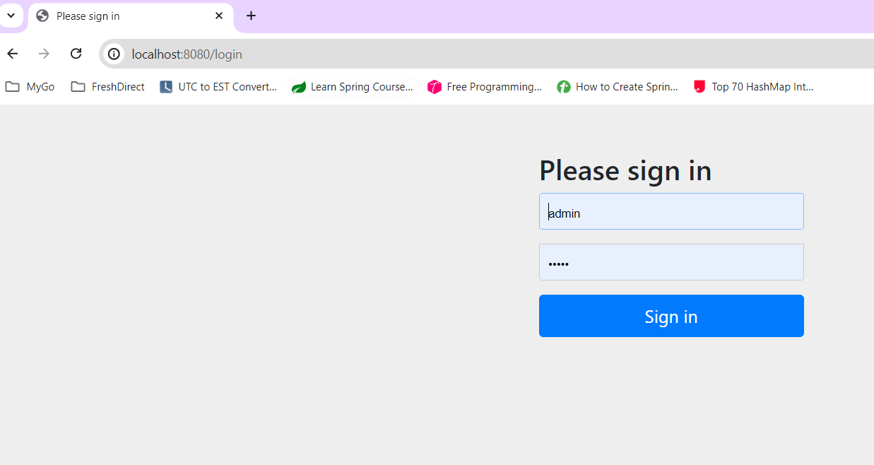

After login the application:

URL: <http://localhost:8080/customer/all>

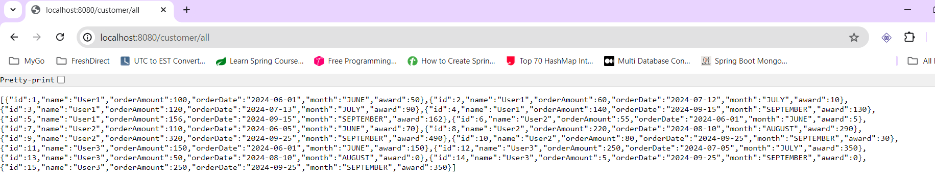

To get the data orders after the provided date

URL : <http://localhost:8080/customer/find/date-after/2024-08-15>

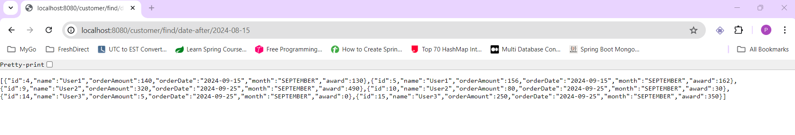

To get the data By Order ID

URL : <http://localhost:8080/customer/3>

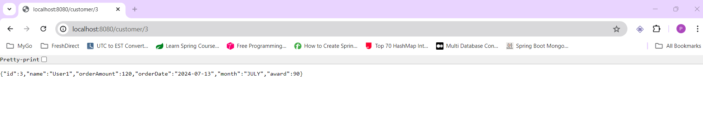

Find By User Name

URL : <http://localhost:8080/customer/find/title/User1>

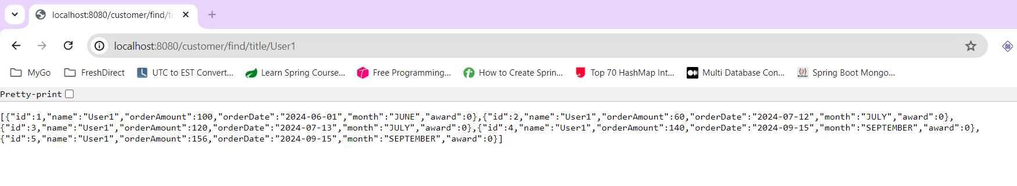

Points Report:

URL : <http://localhost:8080/customer/pointsReport>

